Add Chart

Toolbar / Data / Chart

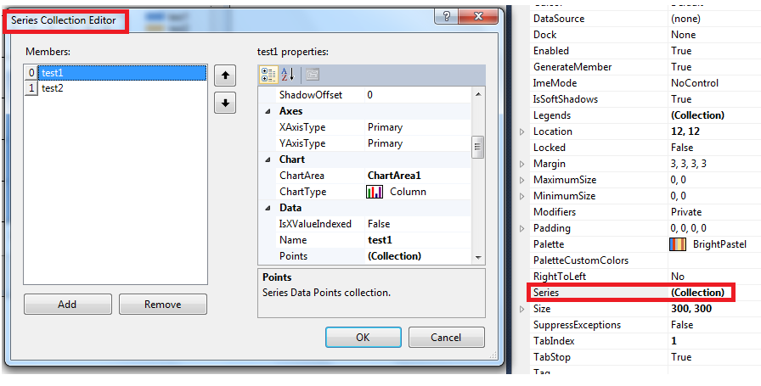

private void button1_Click(object sender, EventArgs e)

{

Random rdn = new Random();

for (int i = 0; i < 50; i++)

{

chart1.Series["test1"].Points.AddXY(rdn.Next(0, 10), rdn.Next(0, 10));

chart1.Series["test2"].Points.AddXY(rdn.Next(0, 10), rdn.Next(0, 10));

}

chart1.Series["test1"].ChartType = System.Windows.Forms.DataVisualization.Charting.SeriesChartType.FastLine;

chart1.Series["test1"].Color = System.Drawing.Color.Red;

chart1.Series["test2"].ChartType = System.Windows.Forms.DataVisualization.Charting.SeriesChartType.FastLine;

chart1.Series["test2"].Color = System.Drawing.Color.Blue;

}

using System;

using System.Windows.Forms;

using System.Windows.Forms.DataVisualization.Charting;

namespace WindowsFormsApplication1

{

public partial class Form1 : Form

{

public Form1()

{

InitializeComponent();

}

private void Form1_Load(object sender, EventArgs e)

{

// Data arrays.

string[] seriesArray = { "Cats", "Dogs" };

int[] pointsArray = { 1, 2 };

// Set palette.

this.chart1.Palette = ChartColorPalette.SeaGreen;

// Set title.

this.chart1.Titles.Add("Pets");

// Add series.

for (int i = 0; i < seriesArray.Length; i++)

{

// Add series.

Series series = this.chart1.Series.Add(seriesArray[i]);

// Add point.

series.Points.Add(pointsArray[i]);

}

}

}

}